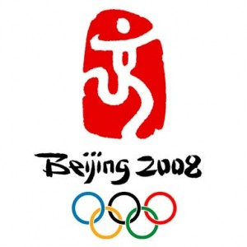

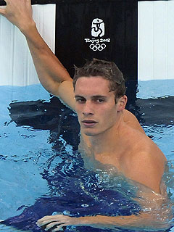
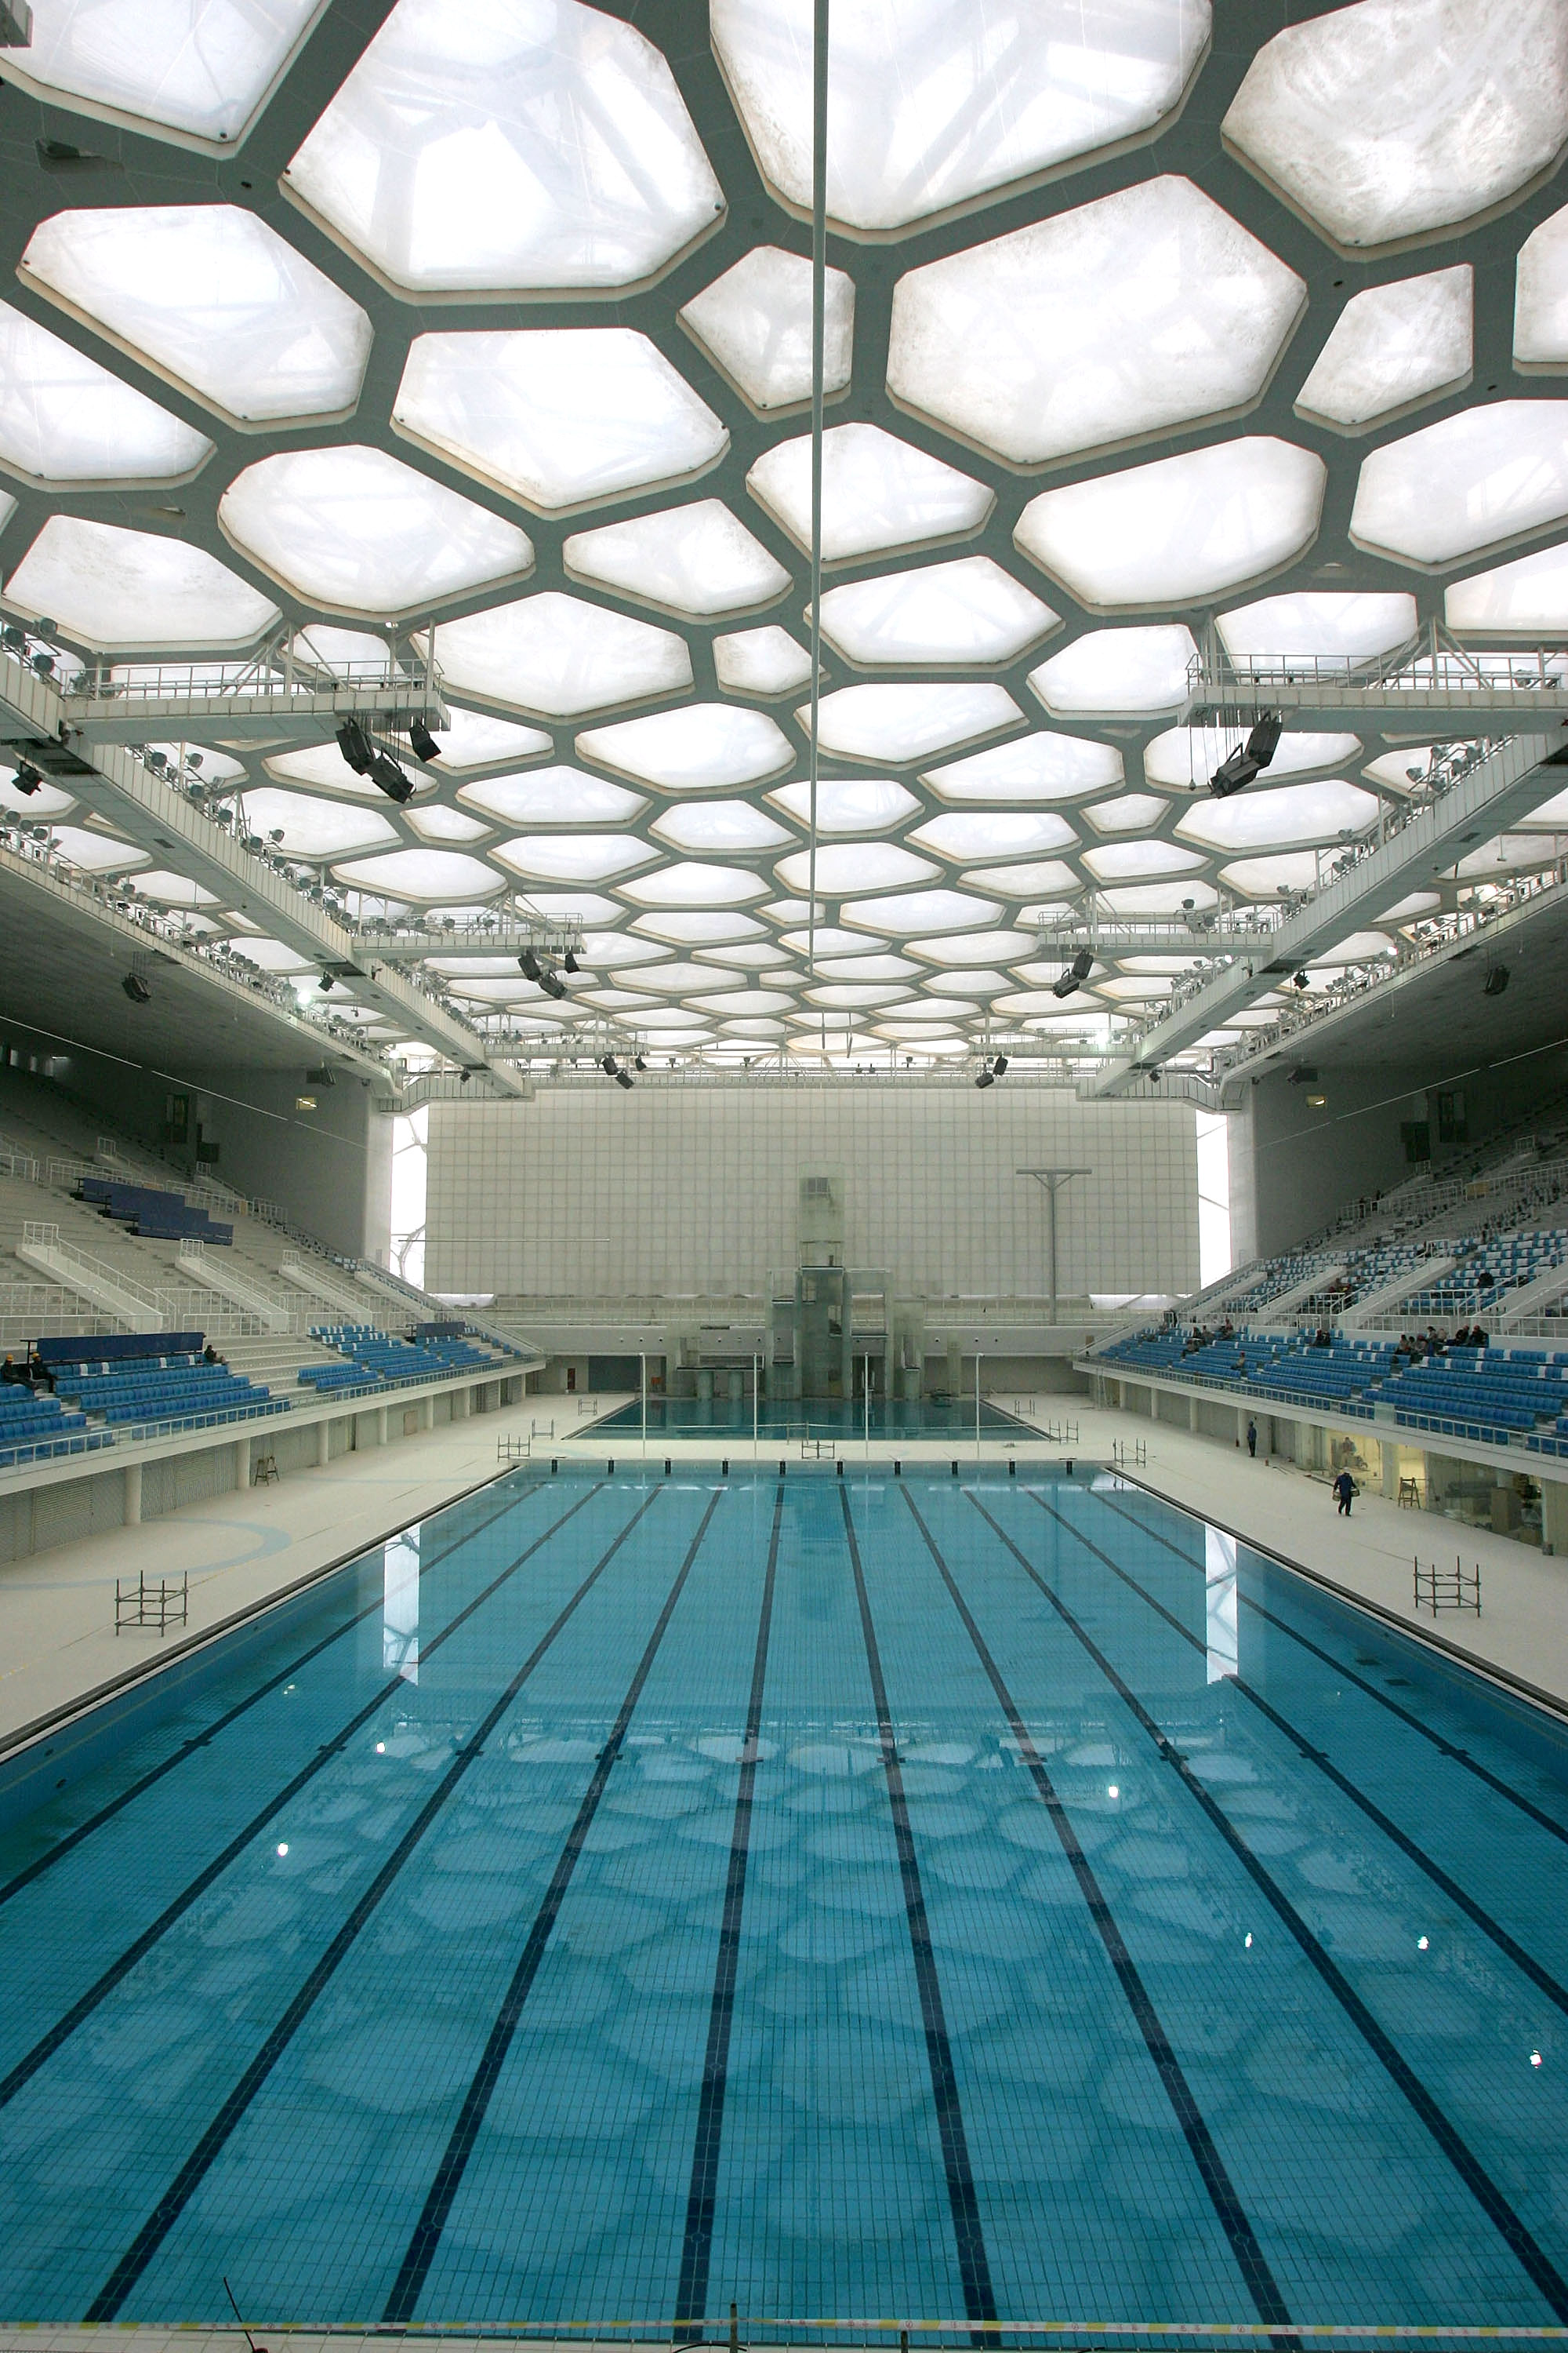

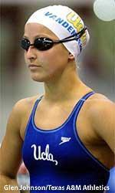
Michael Phelps
Kim Vandenberg
Megan Jendrick
Eric Shanteau

EVENTS
Freestyle
50 m |  | men |  | women
100 m |  | men |  | women
200 m |  | men |  | women
400 m |  | men |  | women
800 m |  |  |  | women
1500 m |  | men
Backstroke
100 m |  | men |  | women
200 m |  | men |  | women
Breaststroke
100 m |  | men |  | women
200 m |  | men |  | women
Butterfly
100 m |  | men |  | women
200 m |  | men |  | women
Individual medley
200 m |  | men |  | women
400 m |  | men |  | women
Freestyle relay
4×100 m |  | men |  | women
4×200 m |  | men |  | women
Medley relay
4×100 m |  | men |  | women
Marathon
10 km |  | men |  | women

Rank | Nation | Gold | Silver | Bronze | Total
1 | United States (USA) | 14 | 10 | 10 | 34
2 | Australia (AUS) | 6 | 6 | 8 | 20
3 | Great Britain (GBR) | 2 | 2 | 2 | 6
4 | Japan (JPN) | 2 | 0 | 3 | 5
5 | Germany (GER) | 2 | 0 | 1 | 3
6 | Netherlands (NED) | 2 | 0 | 0 | 2
7 | China (CHN) | 1 | 3 | 2 | 6
8 | Zimbabwe (ZIM) | 1 | 3 | 0 | 4
9 | France (FRA) | 1 | 2 | 3 | 6
10 | Russia (RUS) | 1 | 1 | 2 | 4
11 | Italy (ITA) | 1 | 1 | 0 | 2
 | South Korea (KOR) | 1 | 1 | 0 | 2
13 | Brazil (BRA) | 1 | 0 | 1 | 2
14 | Tunisia (TUN) | 1 | 0 | 0 | 1
15 | Hungary (HUN) | 0 | 3 | 0 | 3
16 | Norway (NOR) | 0 | 1 | 1 | 2
17 | Slovenia (SLO) | 0 | 1 | 0 | 1
 | Serbia (SRB) | 0 | 1 | 0 | 1
19 | Austria (AUT) | 0 | 0 | 1 | 1
 | Canada (CAN) | 0 | 0 | 1 | 1
 | Denmark (DEN) | 0 | 0 | 1 | 1
Total |  | 34 | 34 | 36 | 104

